

**PUBLIC TRANSPORT**

**OPTIMIZATION**

# GROUP MEMBERS

KRISHNA

ARUNKUMAR

VIGNESH

HARIHARAN

VIBISHMAN

# INTRODUCTION

"In today's urban landscape, the Internet of Things (IoT) is revolutionizing public transport. This interconnected network of smart devices, sensors, and data analytics optimizes efficiency, enhances passenger experiences, and addresses longstanding challenges. IoT is driving the future of urban mobility, reshaping how we move within our cities."

# PROJECT DEFINITION

1. **Objective Definition:**

Clearly outline project goals and objectives, emphasizing improved efficiency and the quality of public transportation services.

1. **IoT Sensor System Design:**

Design a robust IoT sensor system, specifying the types of sensors required, data collection methods, and data transmission protocols.

# PROJECT OBJECTIVES

The project aims to enhance public transportation by delivering real-time information to passengers, predicting vehicle arrival times, monitoring ridership levels, and ultimately improving the quality of service. This will be achieved through the integration of IoT sensors and Python technology, ensuring efficient and reliable public transit.

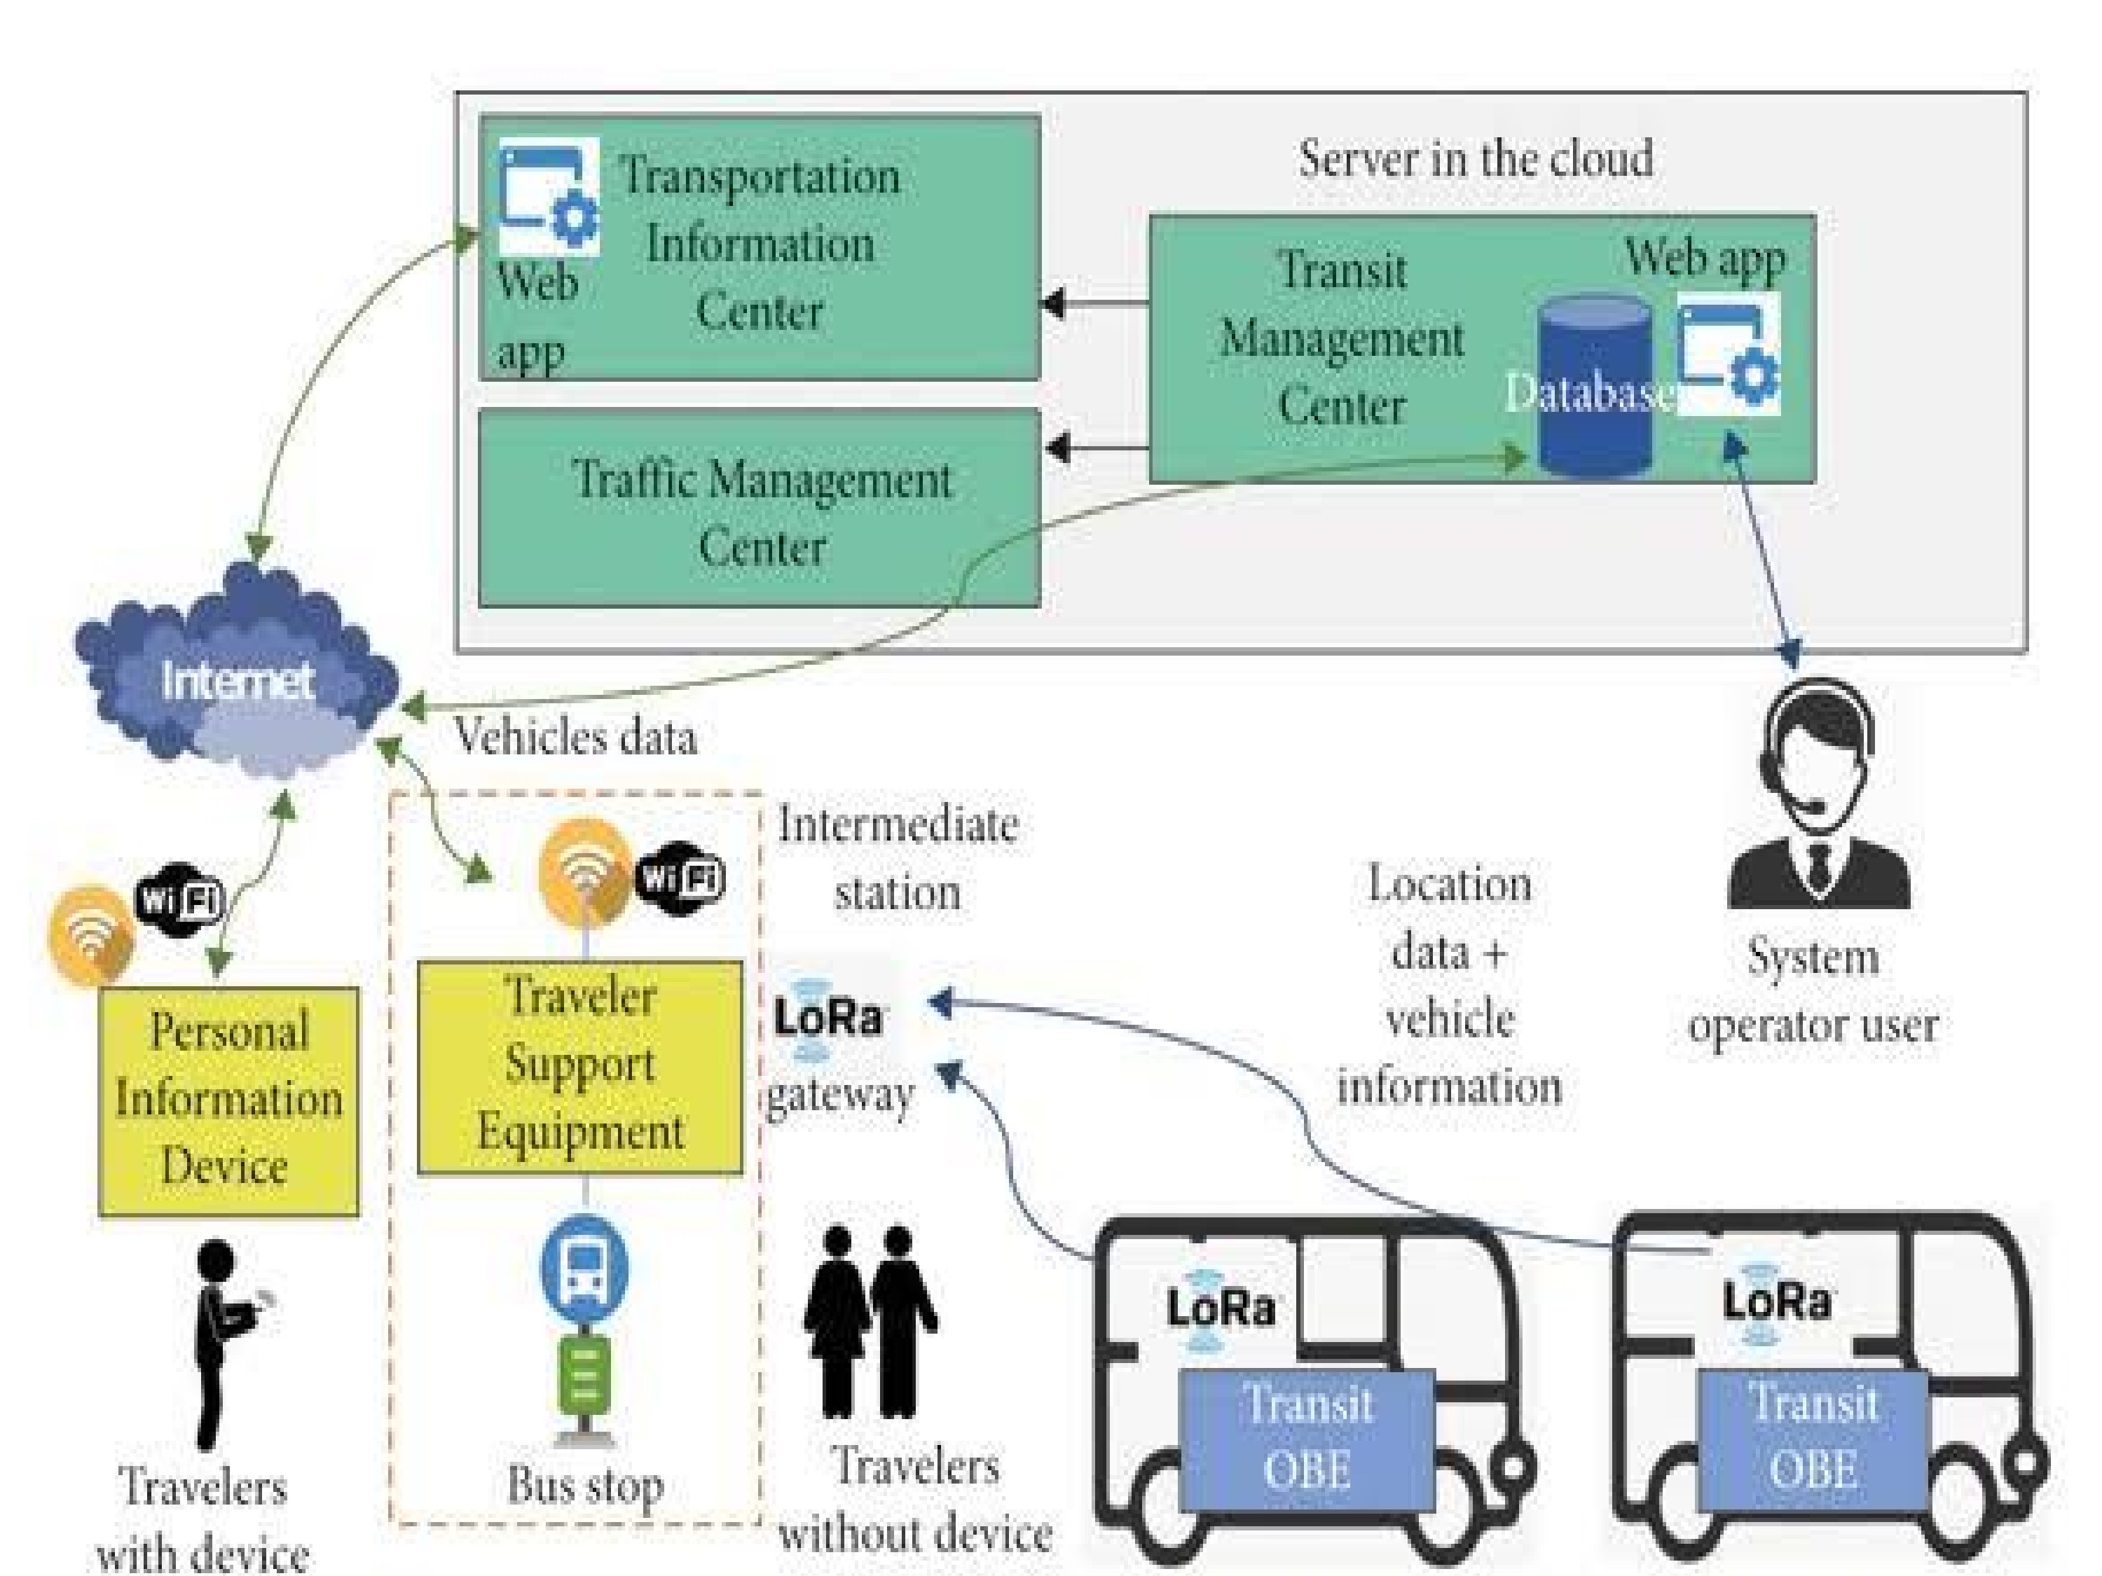

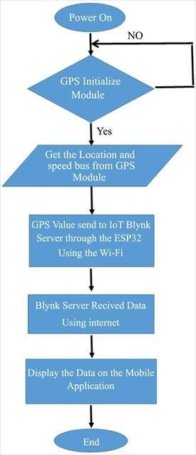This project seeks to elevate public transportation by employing IoT sensors and Python technology. It endeavors to furnish real-time transit data, forecast vehicle arrival times, and observe ridership trends.

**IOT SENSOR DESIGN**

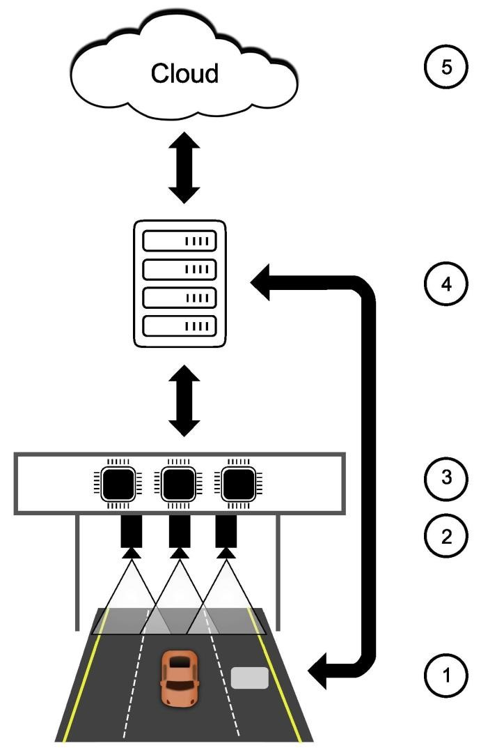

For the IoT sensor design, we'll carefully select sensors like GPS and passenger counters, determine their optimal placement, plan data transmission and power supply, set up data storage, calibration, and redundancy measures. This thoughtful design ensures accurate data collection and integration into the transit information platform.

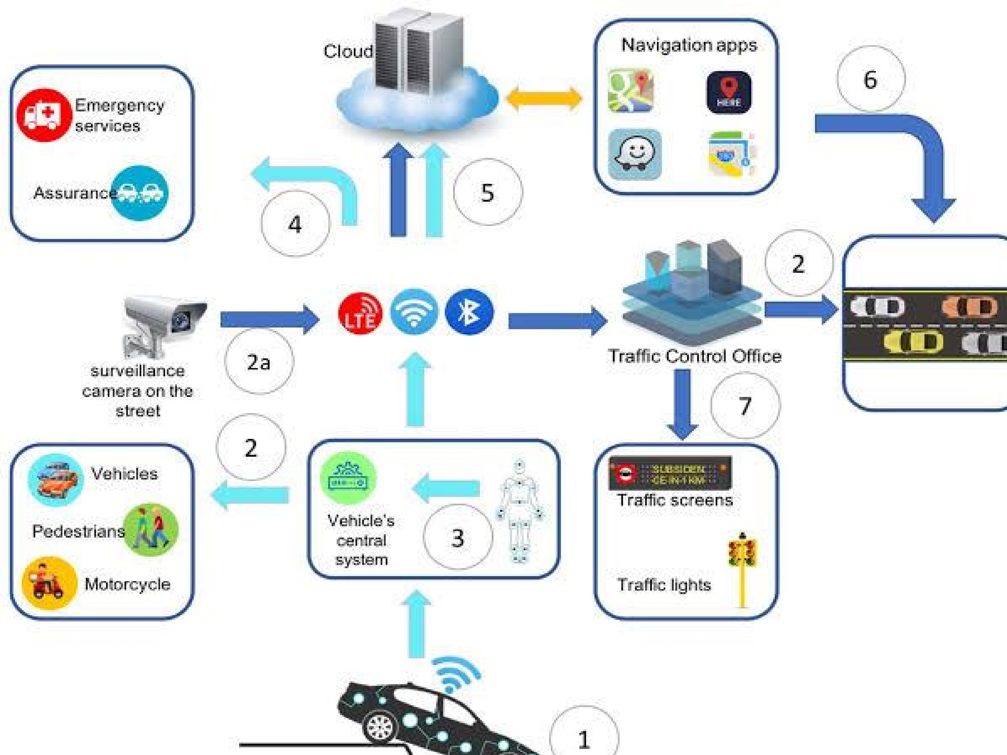

# IOT SENSOR DESIGN

In the IoT sensor design phase, we’ll meticulously select and deploy sensors such as GPS for location tracking and passenger counters to monitor occupancy within public transportation vehicles. Strategic sensor placement will be determined to ensure precise data collection. We’ll establish robust data transmission mechanisms, considering communication protocols and reliability. A reliable power supply, whether through batteries or vehicle power

integration, will be secured to sustain sensor operations. Data storage solutions will be implemented, addressing storage capacity and data retention requirements. Calibration and maintenance protocols will be established for data accuracy.

**REAL TIME TRANSIT INFORMATION PLATFORM**

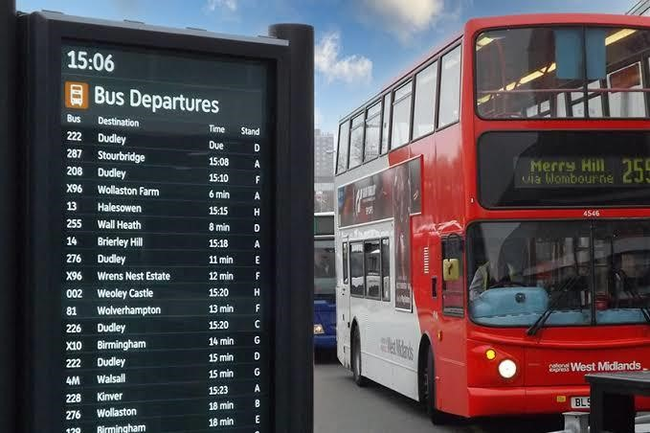

Design a user-friendly web-based platform for real-time transit information. Features include data integration with IoT sensors, interactive maps, predictive arrival times, mobile accessibility, user authentication, data visualization, alerts, accessibility compliance, security, scalability, and a feedback mechanism. Enhance passenger experience and encourage public transportation usage.

